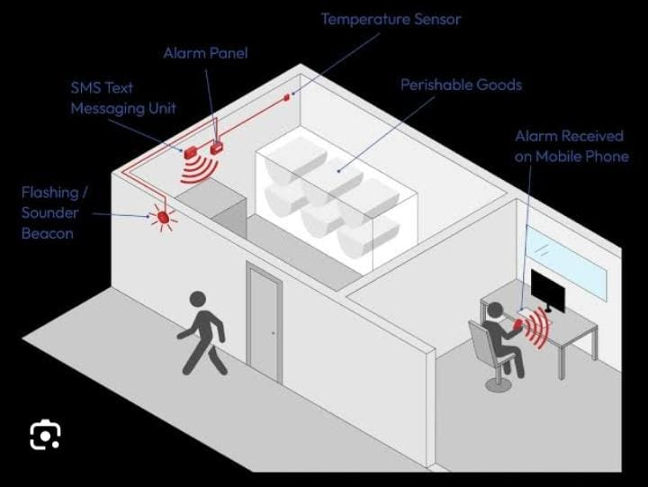

Team

ID

:

NM2023TMID12362

Team

Leader

:

Parvathi Das S

Ragini ST

Bhavadharani K

PROJECT

DOCUMENTATION

Joy Briskilla J

Team Members

INDUSTRIAL WORKERS HEALTH AND SAFETY SYSTEM BASED ON INTERNET OF THINGS

INTRODUCTION:

Project Overview:

* In this paper, Industrial workers health and safety system based on using Internet of Things(IOT) and cloud computing technologies.
* Temperature sensors with a high level of accuracy are expensive, which is mainly due to the required calibration and trimming procedures.
* Moreover, the accuracy should regularly be checked and care should be taken during application, for instance, during thermal cycling or a heavy mechanical load, that the required accuracy is still maintained.
* In many industrial applications, stability and good resolution over a certain time interval are more important than accuracy with respect to standards.
* Thermal sensors track temperature changes. In many process industries, temperature sensors are used to measure gas, liquid, and solid thermal properties and are intended for general as well as for specific purposes.

Purpose:

* Nowadays, temperature sensors have many applications in the IoT area, such as monitoring and controlling temperature in smart homes, industrial plants, and medical facilities.
* To use temperature sensors, they must be connected to a microcontroller or other IoT device.

Coding and Stimulation:

Wokwi Project Link:

<https://wokwi.com/projects/365257218451024897>

Features 1:

* Save time with instant notifications and alerts:
* Productivity improvement with advanced analytics.
* Maintaining regulatory compliance
* Accessibility from remote location
* Creating transparency in the supply chain

Source code:

float temp;

int tempPin = 0;

void setup() {

Serial.begin(9600);

}

void loop() {

temp = analogRead(tempPin);

// read analog volt from sensor and save to variable temp

temp = temp * 0.48828125;

// convert the analog volt to its temperature equivalent

Serial.print("TEMPERATURE = ");

Serial.print(temp); // display temperature value

Serial.print("*C");

Serial.println();

delay(1000); // update sensor reading each one second

}

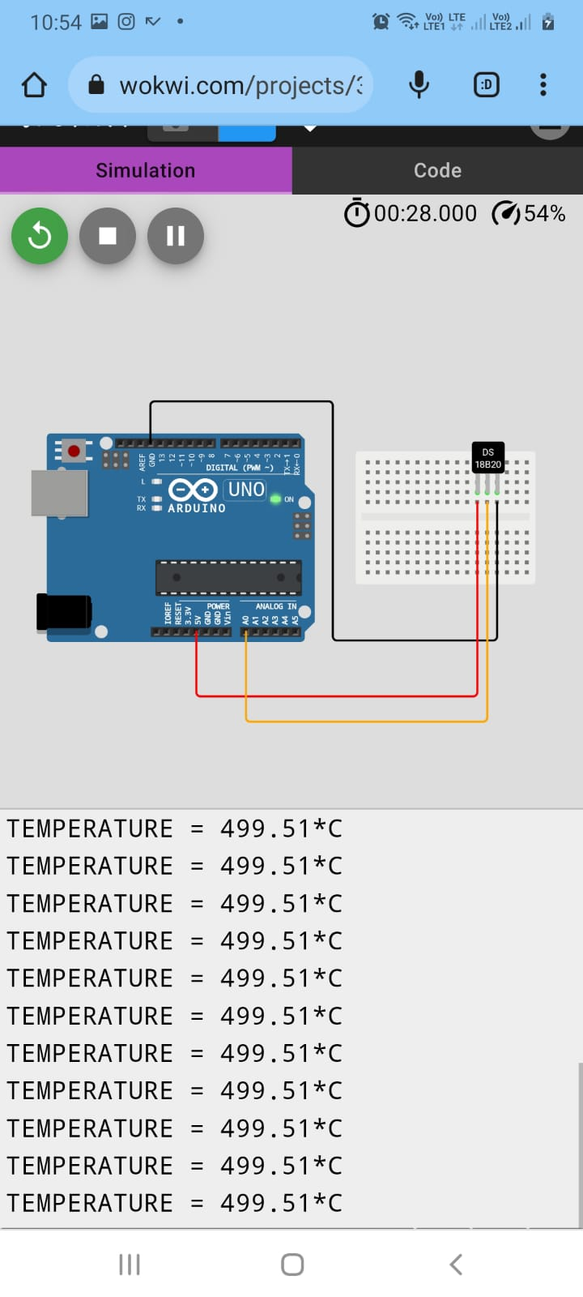

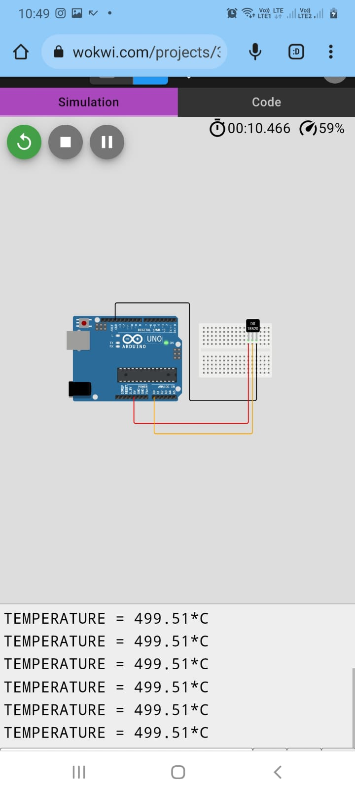

Running

Simulation:

➢

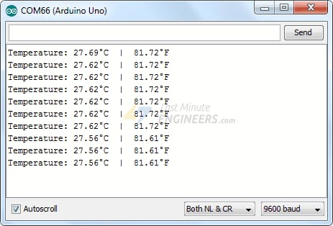

Features

2:

A

user

interface

is

developed

using

the

following

services:

IBM

IT

Watson

Platform

Node-Red

service

Wokwi

simulation

web

Application

Python

IDLE

Results:

Performance

Matrics:

IBM

Watson

Platform:

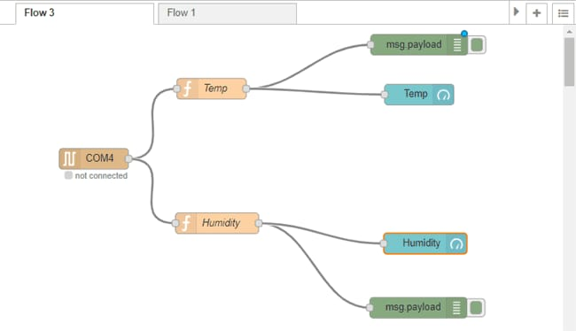

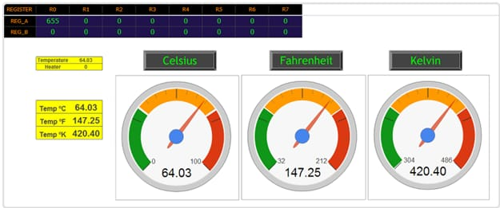

Advantages and Disadvantages:

i) Advantages:

* Advantages or benefits of thermistor:
* It is a small size
* Highly sensitive allows them to work well over a small temperature range
* They are more sensitive than other temperature sensors
* Easy to use
* They are fast in operation
* It has good sensitivity in NTC region
* Fast response over the narrow temperature range
* Cost is low
* Very responsive to changes in temperature
* High accurate
* Repeatable
* It does not require contact and leads resistance problem not occurred due to large resistance
* Options for customization
* Easily interfaced to electronics instrumentation
* it requires a standard two-wire connection system means they are compatible with many devices.
* ii)Disadvantages:
* Thermistor need for shielding power lines
* Extremely non-linear
* Passive
* The thermistor is not suitable for a large temperature range
* The resistance temperature characteristics are nonlinear
* Narrow working temperature range compared to other sensors such as RTD and thermocouple
* More fragile as they are semiconductor devices
* Susceptible to self-heating errors
* The excitation for large temperature range

Conclusion:

* The use of temperature monitoring sensors has enabled the monitoring of change in temperature affecting the quality of the products.
* Their implementation in different sectors has empowered the logistics and warehousing operations of a company.
* The solution these sensors offers along with IoT allows companies to monitor the temperature of their products in a cold chain.
* This is enabling companies to ensure the quality of their products while they are in transit.
* Future Scopes:
* Gas turbines are heat-generating engines that combine air and gas and ignite the two to produce electricity. In instances where the air contains ice particles that have the potential to damage the turbine blades, the temperature sensors will pick up the fault and notify the team before there is more damage.
* An (R&D) Engineer without the right knowledge about sensors will find it extremely challenging to successfully implement new sensor technologies.
* Safety will also improve because unsafe situation will be easily predicted.
* implementation of thermal sensors or cameras by mobile phone/tablet manufacturers and other consumer devices.
* The sensor’s advantage is saving you from premature failure of machinery.
* It detects any change in the temperature that might affect the equipment.
* It sends a warning sign before an impending issue, where it is, and possible diagnostics make it easier for the maintenance team to address the issue before it results in more damage.
* - It does not take away the team but helps work more efficiently.

|  |  |  |
| --- | --- | --- |
| Source code : wokwi device stimulation source code:  **Appendix:**  // #include <MD_Parola.h>  // #include <MD_MAX72xx.h>  // #define HARDWARE_TYPE MD_MAX72XX::PAROLA_HW  // #define MAX_DEVICES 4  // #define CS_PIN 3  // MD_Parola myDisplay = MD_Parola(HARDWARE_TYPE, CS_PIN, MAX_DEVICES);  // const float BETA = 3950; // should match the Beta Coefficient of the thermistor  // void setup() {  //  // put your setup code here, to run once:  // myDisplay.begin();  //  // Set the intensity (brightness) of the display (0-15):  // myDisplay.setIntensity(0);  //  // Clear the display:  // myDisplay.displayClear();  // float celsius;  // myDisplay.displayText(celsius, PA_CENTER, 100, 0, PA_SCROLL_LEFT, PA_SCROLL_LEFT);  // Serial.begin(9600);  // }  // void loop() {  // // put your main code here, to run repeatedly:  // // myDisplay.setTextAlignment(PA_CENTER);  // // myDisplay.print("Temperature");  // int analogValue = analogRead(10);  // float celsius = 1 / (log(1 / (1023. / analogValue - 1)) / BETA + 1.0 / 298.15) - 273.15;  // Serial.print("Temperature: ");  // Serial.print(celsius);  // Serial.println(" ℃");  // delay(2000);  // if (myDisplay.displayAnimate()) {  // myDisplay.displayReset();}  // }  #include <MD_Parola.h>  #include <MD_MAX72xx.h>  #define HARDWARE_TYPE MD_MAX72XX::PAROLA_HW  #define MAX_DEVICES 4  #define CS_PIN 10  MD_Parola myDisplay = MD_Parola(HARDWARE_TYPE, CS_PIN, MAX_DEVICES);  const float BETA = 3950; // should match the Beta Coefficient of the thermistor  void setup() {  myDisplay.begin();  // Set the intensity (brightness) of the display (0-15):  myDisplay.setIntensity(0);  // Clear the display:  myDisplay.displayClear();  }  void loop() {  int analogValue = analogRead(A0);  float celsius = 1 / (log(1 / (1023. / analogValue - 1)) / BETA + 1.0 / 298.15) - 273.15;  String temp = (String) celsius;  myDisplay.print(temp);  delay(1000);  ………………………………………………………………………………………………………………………………………………}  **Source code : Python Publish Source Code**  import glob  import time  RATE = 30  sensor_dirs = glob.glob("/sys/bus/w1/devices/28*")  if len(sensor_dirs) != 0:  while True:  time.sleep(RATE)  for directories in sensor_dirs:  temperature_file = open(directories + "/w1_slave")  # Reading the files  text = temperature_file.read()  temperature_file.close()  # Split the text with new lines (\n) and select the second line.  second_line = text.split("\n")[1]  # Split the line into words, and select the 10th word  temperature_data = second_line.split(" ")[9]  # We will read after ignoring first two character.  temperature = float(temperature_data[2:])  # Now normalise the temperature by dividing 1000.  temperature = temperature / 1000  print 'Address : '+str(directorie |  |  |

# “THANKYOU”